

Universidade Federal de Pernambuco
Centro de Informática

Curso Seqüencial de Formação Complementar em Análise de Testes
Turma 3

Automated Tests and Process with PTF Add-on V3.0

Authors
José Elias Queiroga da Costa Araújo (jeqca@cin.ufpe.br)
Marcello Alves de Sales Junior (masj2@cin.ufpe.br)
Supervisor
Prof. Dr. Alexandre Vasconcelos
Recife, Pernambuco-Brazil, August 2004
Acknowledgments
The authors of this monograph would like to thank for the great and pleasant opportunity of the CIn–STP, especially for Professor Alexandre Vasconcelos for his supervision and each CIn Professor, as well as all Motorola’s scholarship holders and Motorolans from BDC and CIn-STP, who contributed directly or indirectly to this accomplishment. Finally, it would not be possible without the Motorola’s support for this project.

Abstract

Most of times, schedule and minimal resources takes software project managers and developers to face the challenge of doing the project within an ever-shrinking schedule and with minimal resources. As part of their attempt to do more with less, organizations want to test software adequately, but as quickly and thoroughly as possible. Motorola has used the Phone Test Framework (PTF) in order to automate its test cases as an attempt to overcome such challenge. Nevertheless, the PTF use involves a lot of complex configuration steps, a poor user interface and the most important, the lack of management of its results, which makes the testing process difficult and delayed. For these reasons, a new version of PTF Add-on, one of the CIn-STP monograph results, was designed to accomplish and improve the automated test process together with PTF. PTF Add-on V3.0 manages the configuration steps and the execution results with a wizard-like design, allowing the tester to save important time during the testing process.

Resumo

Na maioria das vezes, o calendário e recursos mínimos fazem com que os gerentes de projeto e desenvolvedores de software a enfrentem o desafio de fazer o projeto com um calendário misturado e recursos mínimo. Como parte de suas tentativas de fazer mais com menos, as empresas querem testar software o mais rapidamente e adequadamente possível. A Motorola tem usado o Phone Test Framework (PTF) a fim de automatizar seus casos de teste como uma tentative de vencer tal desafio. Entratanto, o uso do PTF envolve uma gama de passos de configuração complexas, uma pobre interface com o usuário e o mais importante, a falta de gerenciamento de seus resultados, o que faz do processo de teste difícil e demorado. Por essas razões, uma nova versão do PTF add-on, um dos resultados do projeto de Imersão do CIN-STP, foi modelado para realizar e melhorar o processo de testes automáticos junto com PTF. PTF Add-on V3.0 gerencia os passos de configuração e os resultados da execução com um modelo de wizards, permitindo ao testador salvar um tempo importante durante o processo de teste.
Figures List
Figure 2-1: Wizard Steps of Execution Pre-Requirements 11
Figure 2-4: The Context-Free Grammar to the Log Parser 13
Figure 3-1: PTF Add-on Use Case Diagram 14
Figure 3-2: The kernel components of PTF Add-on 19
Figure 3-3: Execution Component 20
Figure 3-4: Log Parser Component 21
Figure 3-5: XLS Report Creator Component 23
Figure 3-6: Test Central Results Sender Component 24
Figure 3-7: Execution Wizard Component 24
Figure 3-8: PTF Add-on Multi-Layer Diagram 25
Figure 3-9: PTF Add-on Deployment Diagram 26
Figure 4-1: PTF Add-on Business Process Model 27
Figure 4-2: PTF Add-on configuration keys 29
Figure 4-3: The Workspace structure directory 30
Figure 4-4: Create a new Execution 31
Figure 4-5: Execution Wizard Frame 32
Figure 4-6: Selecting a test case list from .jar or .txt file 33
Figure 4-7: Defining the test cases list 34
Figure 4-8: Selecting the configuration file 34
Figure 4-9: Opened PTF-TAF Configuration file. 35
Figure 4-10: Opening an existing Execution Wizard Configuration file with .ptfaddon extension 36
Figure 4-11: Multiple Configuration Wizard Windows 37
Figure 4-12: Execution TAB from the Wizard. 38
Figure 4-13: Test Execution in process. 39
Figure 4-14: Multiple Execution Shots on different hardwares 39
Figure 4-15: Results TAB 40
Figure 4-16: Generated Report from the Execution Results 41
Figure 4-17: Sent Results on the Motorola Test Central 42
Figure 4-18: Sent Results on Test Central Repository 42
Figure 4-19: Report Generation Utility 43

Content
1. Introduction and Motivation 6
2. PTF Add-on New Requirements 9
2.1. Test Tool Requirements 9
2.2. Engineering the requirements 10
3. PTF Add-on 3.0 Environment Modeling 14
3.1. Requirements 14
3.2. Components Model 18
3.2.1. Execution Component 20
3.2.2. Log Parser Component 21
3.2.3. Report Generation Component 22
3.2.3.1. XLS Report Creator 22
3.2.3.2. Test Central Results Sender 23
3.2.4. Execution Wizard Component 24
3.3. Architectural model 25
3.4. Deployment 26
4. Automated Testing Process with PTF Add-on 27
4.1. Environment Set Up 29
4.2. Test Execution 37
4.3. Report Generation 40
5. Conclusions and Future Work 44
References 46
Appendices 47

Introduction and Motivation
Software project managers and developers of today’s applications face the challenge of doing so within an ever-shrinking schedule and with minimal resources. As part of their attempt to do more with less, organizations want to test software adequately, but as quickly and thoroughly as possible. To accomplish this goal, organizations like Motorola are turning to automated testing [Dustin at al, 1999].
Nowadays, Motorola has given attention to testing automation in order to have better quality on its products, as well as a faster time-to-marketing of its inventions. For this reason, frameworks and components like the Motorola Phone Test Framework [PTF, 2003] (PTF) have been released by its automation group to improve the automated testing process of its handset products before they reach the consumers.
The current PTF version expects the tester to provide a test list and a configuration file. The last one needs the following mandatory parameter values:
- Path to DRM's File (Data Resource Manager);
- Path to the language file;
- Path to flex file;
- Cell phone communication port;
- Path to the log file to be generated;
- Other personalized parameters like used number of the SIM card, etc.
The test list is deployed in Jar files, containing the java classes that implement the test cases using the TAF framework [TAF, 2002]. Then, the tester describes the test suite in a text file, with the test cases to be executed, matching that ones inside the jar file. After creating the configuration and test list files, the following command line executes the automated test suite:
- Java phonetest.TSM –l <test suite file> -c <config file>
Other observation that is needed to give attention to is that the tester must publish the test case jar file on the classpath of the system. The execution’s result is a report flat file in text format, as show in Figure 1-1. The complete syntax of the configuration and the test list files are described in [Cruz, 2003], as well as the complete steps for the basic execution of PTF.
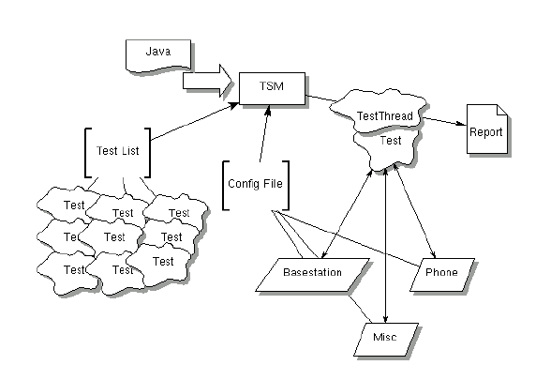
Figure 1-1: Automated Test Execution with PTF

In spite of working, the PTF use involves a lot of complex steps of configuration all the time the tester will run a tests suite. As seen, configuration files, command-line use and lack of management of results are some of its pitfalls that make the process of testing delayed.
For these reasons, some project results from Motorola Internship program on this site have tried to improve the main key functionalities of that framework. One result is PTF Add-on, which was firstly proposed by Cruz [Cruz, 2003] as a “configuration skin”, built to reduce the configuration time and number of repetitive tasks the tester should make in order to have the environment ready to use. Cruz also identified on his monograph’s future work section some interesting points that have motivated our work: run time indication of test case status, visualization of test execution time and indication of tests that had failed during the tests.
In order to address the problem of the command-line, the second version of PTF Add on [Filho et al, 2003] came as an environment to incorporate PTF, allowing the user to set the PTF environment and running the automated tests inside the application. Nevertheless, the results are similar to the first version and the tester continued with the same functionalities.
Whereas the first two versions of PTF Add-on had tried to accomplish the setup problems of the automation process, the results of this work tries to attack the same referred major problems in a different way: identifying the key problem that is the lack of management of the PTF results, which is the main output artifact after its execution. Moreover, some reuse possibilities should also be addressed by an environment that would enable the tester multiple executions of different test suites, for instance, as well as the reuse of a previous configuration definition created by the tester, and so on.
As a consequence, PTF Add-on V3.0 is the result a new environment of automated tests worried with productivity, offering an intuitive wizard to setup the environment, as well as a friendlier presentation of the log results, among others.
Besides the current chapter, this monograph is organized as follows: chapter 2 introduces the key requirements of automated software testing, concerning PTF together with the new version of PTF Add-on; Chapter 3 shows the environment modeling; Chapter 4 contextualizes the environment, describing it and proposing a process with the tool and finally chapter 5 shows the outcome of the present work, addressing the future works and improvements to this environment.

PTF Add-on New Requirements
Adoption of automated test tools will not immediately reduce the test effort. A primary impetus for introducing an automated test tool as part of a project is to reduce the test effort. As described in [Dustin at al, 1999], experience has shown that a learning curve is associated with attempts to apply automated testing to a new project and to achieve effective use of automated testing. Therefore, an automated tool requires new skills and additional training. For this reason, a friendlier and intuitive user interface must be offered in order to achieve these points with fewer difficulties.
The new PTF Add-on version should meet the criteria of what the most important output is from the automated process with PTF: the final results generated from the log file. The strategic goal of the automated test effort is to find defects. The use of automated testing can improve all areas of testing, including test procedure development, test execution, test result analysis, error status/correction monitoring, report creation, among others [Dustin at al, 1999]. As a consequence, one of the key features of PTF Add-on is the generation of a friendlier output of PTF generated results. Furthermore, abilities like saving the execution environment set up for a later reuse would be one consideration for improving the process with PTF.

Test Tool Requirements

According to the described topics, it will be presented some of the key features that concentrate the kernel of this PTF Add-on version. Most of them are non-functional requirements and they will be used throughout the whole architecture in a way to achieve the best results as an automated test tool. [Dustin at al, 1999] suggests the following topics as the most reasonable keys of an automated testing tool:
- Platform Support
  - As it’s developed in Java [Gosling & McGilton, 1996], it should run on several platforms, like Windows or Linux based ones;
- Tool Functionality
  - Test result analysis is one of the main key points, and it must allow the tester to easily see whether tests have passed or failed. Using PTF, PTF Add-on must offer a parser to improve the legibility of its generated results from the test results;
  - The test results should be displayed during execution time, while they are being performed and after the execution of each test case;
  - Multiple executions of automated tests must be possible in order to let the tester perform tests using different platforms at the same time.
- Reporting Capability
  - Different report formats should be offered to let the tester with different possibilities to easily report the tests;
  - The test results should be sent to a centralized repository, like Motorola Test Central [Test Central Guide, 2003], after completing the execution;
  - Use of Microsoft Excel format (.xls) report templates to generate the final report artifact from the environment.
- Automated Process
  - The configuration steps of the settings could be saved for a latter use. The automation of the environment preparation could help the tester to reduce the set up time, helping the tester to reuse the information already created.

Engineering the requirements

PTF Add-on V3.0 uses an intuitive graphical interface to enable the specified requirements of the previous section. The most important thing is the separation of concerns, that is, an automated execution will have its own configuration descriptions and execution process, as well as its result information. Each execution will be separated in a wizard window containing the following steps of configuration, also seen in Figure 2-2:

- Basic Configuration Settings: User Core ID, build, platform, and other information about the tests;
- Test list: The list of tests to be executed, uploaded from a Jar file of the test cases or from an existing .txt test list file, previously created by the tester;
- Configuration File: it is the main configuration file needed to run PTF along with TAF.

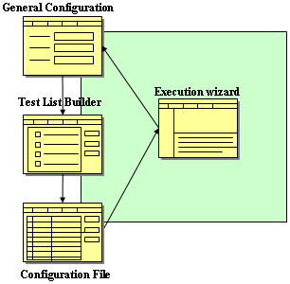
Figure 2-2: Wizard Steps of Execution Pre-Requirements
These steps are preconditions to the environment preparation for the automated testing execution. After completing the wizard configuration, the next step presented to the tester is the execution one. Each wizard processes its own test execution on its own process, as shown in Figure 2-3. The Multiple executions feature of PTF Add-on V3.0 is addressed using this schema, which allows the tester to perform automated execution in different platforms at the same time. As a consequence, each wizard window has its settings, as well as its own log results generated by PTF.
By the time of the wizard set up, the tester can optionally save the configuration information for a later reuse. This is possible using an XML serialization method called Marshall/Unmarshall mechanism [Sosnoski, 2002], which saves the state of each wizard screen on a semi-structured file following the XML Schema [W3C Schema, 2001] definition shown in Figure 2-4. An XML example of a saved wizard is presented on the appendices.

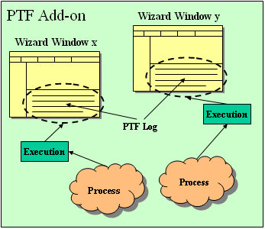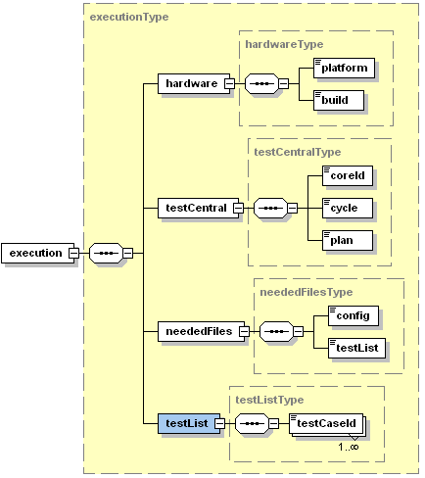
Figure 2-4: Execution Wizard Configuration Format

Figure 2-3: Several Execution Wizard Executions

The execution of the automated testes generates log entries on the output of the process of a specific wizard, and at the same time the log is displayed on a specific view. In order to show the current results, a parser of the log file is used during the execution time to discover the finished test case, its elapsed time and its result. Then, it enables PTF Add-on V3.0 to show the current status of the execution, defining if the last performed test case passed or failed, for instance, as well as showing the exceptions that occurred during the execution, if any. As a consequence, PTF Add-on shows the tree of the executed tests on a view, which allows the tester to visualize each test case “on-the-fly” during the execution of the tests. The parser was implemented using a context-free grammar [Satta, 2000] and it is defined as described in Figure 2-5, as well as on the appendices as a BNF [Ryan at all, 1998].
By means of the parser, the results of the execution are transformed into java beans entities, which represent the test cases and allow the tester to export them to different formats and places. Besides the log file generated by PTF during the tests, the report capabilities of PTF Add-on provide the generation of a well-formatted .xls file containing the results of each test case. Moreover, the test results can be optionally sent to test central after consolidation of the results. This process is shown in Figure 2-6.

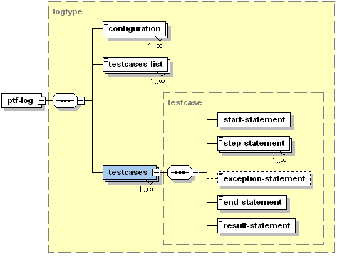
Figure 2-5: The Context-Free Grammar to the Log Parser
All things considered, PTF Add-on new requirements were organized to match the criteria of productivity. Saving the wizard configuration in a file helps the tester with the environment preparation, once the user can reuse the previously created one. After that, the tester executes the automated tests just using the same definition of the wizard and adjusting its values if needed. Finally, it enables the tester to save the results of the generated PTF logs on different resources such as in .xls files or send them to Motorola Test Central Repository. This enables the tester to easily manage the results of the execution and thus, improve the productivity of the automation team.

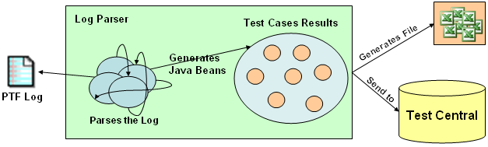
Figure 2-6: Log Parser generating results

PTF Add-on 3.0 Environment Modeling
This chapter describes the whole PTF Add-on environment and its main modules in a button-up way, showing only the main modeling designs of the functional requirements, as well as the components of the tool, finalizing with the multi-layer architecture and the deployment model. It’s important to note that this version of PTF Add-on is a new design of the previous versions, and therefore, there are new contributions to the system.

Requirements

According to the requirements discussed on section 2.2, Figure 3-7 describes the use cases [Canton, 1998] of the discussed environment, defining the main functional requirements of the environment.
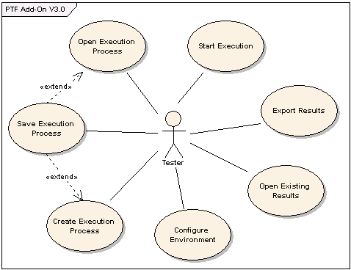
Figure 3-7: PTF Add-on Use Case Diagram
Each Use Case (UC) is as follows:
- Configure Environment UC: The tester configures the PTF Add-on environment, setting resource paths to PTF-TAF package, the workspace directory (described on chapter 4), and other configuration keys.
  - Precondition: Path to PTF-TAF package.
  - Post condition: The environment is ready to execute the PTF-TAF automated tests identifying the PTF local path.
  - Main Flow:
Action | Result
1. The tester chooses to configure the environment; | The form with the configuration keys is shown to the tester.
2. The tester indicates the PTF-TAF package directory key, as well as other optional ones and confirms the configuration. | The environment is ready to run the automated testing cases with PTF Add-on. It’s the requirement before using the tool.

- Create Execution Process UC: The tester creates an execution process, defining the preconditions needed to start running a specified test list. The execution process is presented in a format of steps like a wizard and it’s comprised of ordinary information concerning the tester and used platform, as well as the test list and configuration files. This Execution Process can be optionally saved for future reuse;
  - Precondition: Configure Environment UC.
  - Post condition: The requirements to execute the test suite are set up. The information concerning the test suite and both the test list and configuration files are defined. Optionally, the tester can save the execution process on the disk for future reuse;
  - Main Flow:
Action | Result
1. The tester chooses the option to create a new Test Execution; | A wizard window is presented to the user with the options to be filled;
2. The tester specifies:  - the platform, hardware and build labels;  - The core id, cycle and test plan name. | The test list builder step of the wizard is shown.
3. The tester creates and saves the test list by 2 options:  - Upload the test list from a Jar file or;  - Open an existing .txt test list;  Then the user saves the list. | The configuration file step of the wizard is shown.
4. The tester opens the PTF-TAF configuration file, edits the mandatory keys:  - OBJECT1_CONN = used USB port;  - OBJECT2_ICON_REF_FILE = path to the DRM file;  - OBJECT2_LANGUAGE = path to the language definition file;  - PHONES_FLEX_FILE = path to the hardware flex file. | The execution step of the wizard is shown.

- Save Execution Process UC: The tester saves an Execution Process definition previously defined. The definition is all the steps information of the wizard. This information is serialized as a semi-structured XML file, and saved using the ‘.ptfaddon’ file extension.
  - Precondition: Create Execution Process UC or Open Execution Process UC.
  - Post condition: Saves the execution process wizard, after serializing the execution process, on a device.
  - Main Flow: (after last result of one of the preconditions)
Action | Result
1. The tester chooses to save the Execution process defined on the wizard; | A save file dialog is displayed.
2. The tester indicates the name of the file to be saved. | The execution file is saved on the specified device path.

- Open Execution Process UC: The tester opens an execution process wizard file with all definitions previously defined. After opening it, all the definitions are filled on each of the wizard steps with the saved information.
  - Precondition: Save Execution Process UC has been executed at least one time.
  - Post condition: All the definition of the execution process is loaded from the saved file and all the execution process wizard information is filled with that definition.
  - Main Flow:
Action | Result
1. The tester chooses to open the Execution process previously saved of the wizard; | An open file dialog is displayed.
2. The tester indicates the name of the execution wizard file to be opened. | The execution process information is loaded from the file and it is filled on all fields and components of the wizard window.

- Start Execution UC: The tester starts executing the automated tests defined on the test list. The status of each executed test as well as its information are displayed ‘on- the-fly’ to the tester.
  - Precondition: Create Execution Process UC or Open Execution Process UC.
  - Post condition: The execution of the test cases will begin and the status of each executed test case is shown to the tester. The final report of the execution test suite will be presented to the tester.
  - Main Flow:
Action | Result
1. The tester chooses to execute the execution process on the wizard window; | The automated test execution will begin and the status of each processed test case is shown to the tester. After processing all test cases, the final results are displayed.

- Open Existing Results UC: The tester views the results of any PTF generated log file. In this case, the results from the log will be parsed and the information about each test case will be shown in a formatted way.
  - Precondition: an existing log file generated by PTF.
  - Post condition: the view of the results in a formatted way, which includes the elapsed time of the test suite, as well as the information about each test case, such as the result status and the elapsed time to be executed.
  - Main Flow:

Action | Result
1. The tester chooses to open an existing log file. | An open file dialog is displayed.
2. The tester indicates the name of the log file to be opened. | The results from the log file are parsed and shown to the tester using a pre-defined view of the results.

- Export Results UC: The tester exports the results to a given target resource. The resource can be a Microsoft Excel .xls file with the results presented to the tester, or they can be exported to the Motorola Test Central.
  - Precondition: Start Execution UC: or Open Existing Results UC.
  - Post condition: The results are exported to the specified target resource.
  - Main Flow:
Action | Result
1. With the results of an execution test suite, the tester chooses to export the results. | The system asks the user about the target resource, where the tester wants to export the results.
2. The tester chooses the type of the resource to which he wants to save the results (.xls file or send to Motorola Test Central). | The system asks about the confirmation of the chosen action.
3. The tester confirms the export action. | The system processes the results of the execution test suite and generates the report to the specified type of resource.

In summary, the test cases presented in this section were discussed, resulting in implemented auto-contained components to be shown on the next section.

Components Model

The components were defined based on a high-level analysis of the requirements, making part of the business model of the environment. They are specified in Figure 3-8 and are as the follows:
- Execution Component: it’s the kernel of PTF Add-on responsible for capturing the Operating System Process output from PTF, once it’s executed using the same command-line as described on chapter 1; It also manages the test cases list and the configuration file settings for the execution start process;

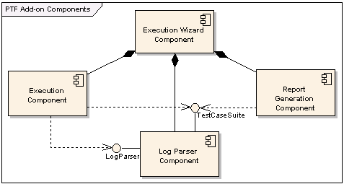
Figure 3-8: The kernel components of PTF Add-on

- Log Parser Component: this component uses the output from the Execution Component to get information about the test cases that were tested. Besides that, it calculates the elapsed time of each test case as well as of the whole test process, among other information concerning the tests;
- Report Generation Component: after completing the execution of the test suite, the report of the application is managed by this component. The tester can optionally save on the Microsoft Excel format (.xls) or send the results to the Motorola Test Central environment;
- Execution Wizard Component: the user interface that gets the tester inputs about the test case suite, as well as the tester information. It is also used to handle the execution process of PTF on a particular screen.

Both the Execution and Report Generation components depend on the Log Parser component as shown in Figure 3-8. Furthermore, the whole information concerning the test suite of the execution process results are generated by the parser.
The Execution Wizard component is the closest component to the tester in the test process. It is composed by the other components and is a graphical interface to get the information from the tester.

Execution Component

The execution component is the kernel of PTF Add-on V3.0. As shown in the class diagram in Figure 3-9, the Execution class encapsulates the necessary information to create an execution command. The information concerning the PTF execution is handled by the TestList and Configuration classes.

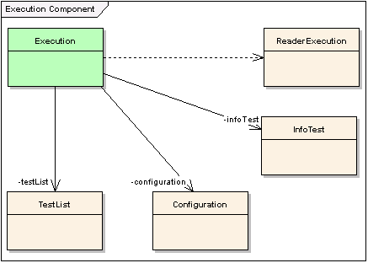
Figure 3-9: Execution Component
The TestList class holds information about the path to the test list file, as well as the chosen test cases to be tested; The Configuration class keeps the path to the PTF-TAF configuration file; finally, the InfoTest class holds the information about the tester and execution process information like the build to be tested and the tester core ID.
The execution of the tests happens as usual: using the command line. By means of the use of the Configuration and the TestList classes, the Execution class gets the correct information about the command to be executed as shown in chapter 1. The difference is that the process output is redirected to the PTF Add-on components, which on its turn get the information about the tests at run time. As a process has its own resources, the Execution class extracts information about each test case that is being executed during the tests execution. As a result, it makes possible to show the tester important information such as how many tests passed and which ones failed.

Log Parser Component

The Log Parser component is comprised of other model classes responsible for the results extracted from the log lines. The LogParser class executes the parser on the log file following the tokens defined on the grammar on the appendices, and shown in Figure 2-5. After completing the parse process, the LogParser class generates its composed class TestCaseSuite, as described in Figure 3-10.

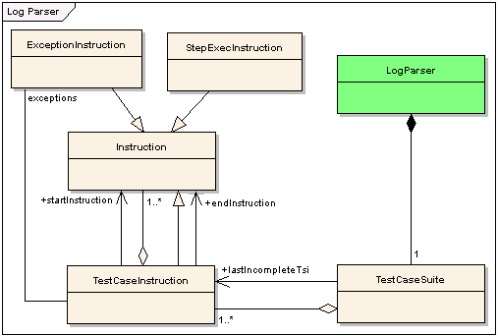
Figure 3-10: Log Parser Component
The Instruction class contains the basic information about a single instruction line of the log file. After being analyzed, the correct instruction class is chosen to be used. As a consequence, the TestCaseInstruction class handles the information about each test case of the execution test suite; the ExceptionInstruction class handles the information about each exception occurred on a given test case, and finally the StepExecInstruction is responsible for the common steps of execution.
The TestCaseSuite class is responsible for calculating the elapsed time of the whole execution process, as well as for handling the information about the number of test cases executed etc. For this reason, the TestCaseSuite class uses an aggregation of TestCaseInstruction to hold the set of all tested test cases identified in the log file. Besides that, it also can keep a reference to the last tested test case instruction that was not completed, if there was any.
The TestCaseInstruction handles information about the result of the test case and its elapsed time. It is aggregated by a set of instructions that may occur on that test case. The instructions are normally StepExecInstruction classes and ExceptionInstruction ones, if any exception occurred during the tests of the specific test suite. In this last case, the TestCaseInstruction will have a separated reference to the occurred exceptions.
As it’s shown, the main Interface to the Log Parser Component is the LogParser class, responsible for handling the information of the test cases suite of the PTF generated log file.

Report Generation Component

PTF Add-on defines two sub-components for the report generation component: the XSL Report Generation and the Test Central Report Sender components. The first one generates a Microsoft Excel XSL report file based on the results of the parser to be saved on the disk. The other sends the results directly to Motorola Test Central.

XLS Report Creator

The XLS Report Creator is responsible for creating the XLS files based on the log output generated by PTF. The XLSReport class is the main class of this component, responsible for getting the information about the test cases to be reported using a reference of the TestCaseSuite class. It also depends on the LogParser class, as described on Figure 3-11, to get the instance of the TestCaseSuite class.
The ExcelCreator manages the creation of the .xls file based on a log report. It depends on the Apache POI sub-framework [Sengupta et al, 2003] that enables the developers to create and edit Microsoft Excel files, using the sub package org.apache.poi.hssf.

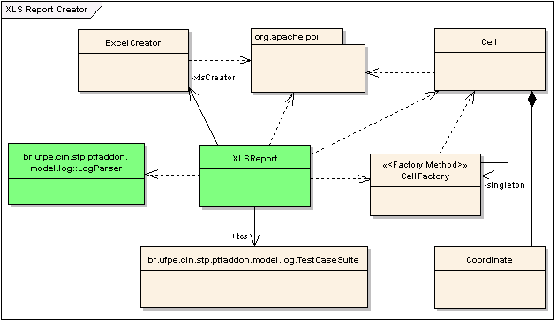
Figure 3-11: XLS Report Creator Component
The representation of a cell on the XLS file is concentrated on the Cell class, whose instances are constructed by the CellFactory class, an implementation of the Factory Method Design Pattern [Gamma et al, 1994]. Finally, the Coordinate class encapsulates the positioning of the cell on the .xls file.

Test Central Results Sender

The component responsible for sending the results to Motorola Test Central is The Test Central Result Sender. As specified in Figure 3-12, the singleton TestCentralResultsSender class uses JDBC classes to send the results directly to the Test Central Database. It uses predefined Store Procedures used from PTF, together with the identification of each tested test case, by means of the TestCaseSuite class.
The correct identification of each test case to the store procedure is gotten from a descriptor file, which describes the identification of the categories of test groups from Motorola. This file must be configured in the case of new test groups used at the Motorola Test Central directories. The information concerning the tester is taken from the Execution class from the Execution Component, which was set up during the configuration steps.

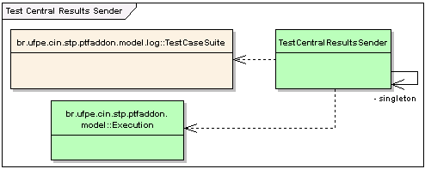
Figure 3-12: Test Central Results Sender Component

Execution Wizard Component

The graphical user interface implementation is developed on this component, which is basically the input to PTF Add-on. The execution wizard component manages the separate execution process screen responsible for the steps of configuration, results and report of an execution with PTF.
As described in Figure 3-13, The MainFrame class is the main window of the application that presents the main menu items to the tester. By choosing the option to create or open an execution wizard process, an instance of JWizardInternalFrame is displayed to the tester with the wizard steps for the test execution and, as a consequence, it’s composed by the Execution class from the Execution Component to show its outputs to the tester.
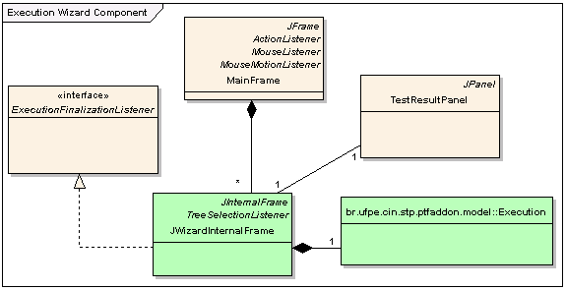
Figure 3-13: Execution Wizard Component
A separate Panel, the TestResultPanel class is used to display the results of the executed tests. JWizardInternalFrame implements the ExecutionFinalizationListener interface to catch the finalization event generated by the Execution class, which indicates the finalization of the automated tests by PTF. The other interfaces not cited on this text make part of the default implementation of the Java Swing Component API [JFC, 2003].

Architectural model

The architectural model shows just the multi-layer diagram of the environment on Figure 3-14. There are only two layers: The View and the Model layers. The view layer contains the user interface classes, used to display the processed model classes from the Model layer.

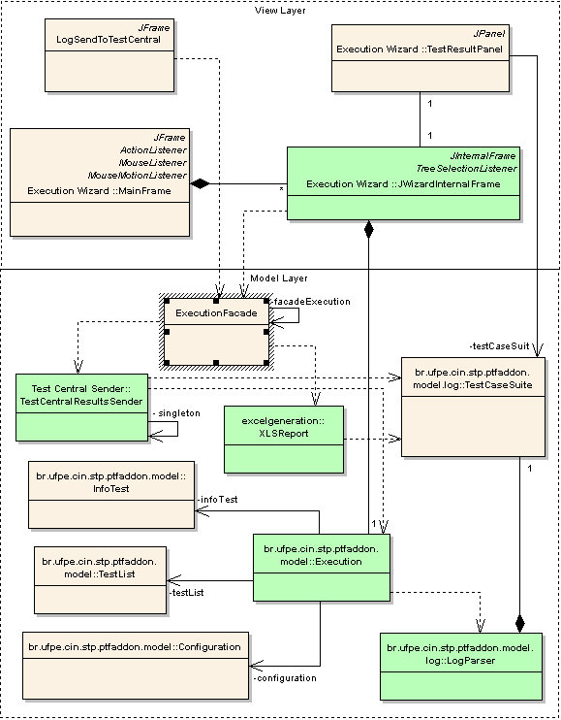
Figure 3-14: PTF Add-on Multi-Layer Diagram

Deployment

Each PTF Add-on implementation is installed on each tester workstation, as usual. The following requirements must be met to have it running:
- JRE 1.4.2 or later [Gosling & McGilton, 1996];
- Latest implementation of PTF-TAF [PTF, 2003];
- Connection to a Motorola private network to send the results;

The deployment model on Figure 3-15 illustrates each of the tester’s PTF Add-on instance, executing tests on a Motorola hardware. After performing the automated tests, the tester generates the results report of a given type: the results can be sent to the Motorola Test Central or they can be exported to an .xls file.


Test Central
Figure 3-15: PTF Add-on Deployment Diagram

Automated Testing Process with PTF Add-on
“A new technology is often met with skepticism – and software test automation is no exception. How test teams introduce an automated software tool on a new project is nearly as important as the selection of the most appropriate test tool for the project.” This citation makes part of the Automated Testing Introduction Process chapter from [Dustin at al, 1999] and shows the importance of a well-defined adoption process of a testing tool. Due to the difficulties faced on this phase, this chapter aims to explain in depth the automated testing process with PTF Add-on V3.0.
The process involves three basic steps: Environment Set Up, Test Execution and Report Generation. The business process diagram in Figure 4-16 basically shows the events, inputs and outputs during the automated testing process with PTF Add-on.

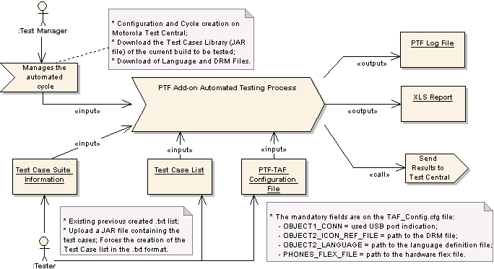
Figure 4-16: PTF Add-on Business Process Model
First of all, the Environment Set Up step concentrates on the system’s required files. The test manager creates the test plan name and cycle on Motorola Test Central following the [Test Central Guide, 2003] as usual, concerning the automated test suite to be performed, as well as the manager downloads the build to be tested. After that, the manager downloads some specific files to the automated tests such as the DRM and Language definition of the hardware. Additionally, the manager can make an update of the test cases definition, identifying the label-version of the test cases in the .jar file. These files are the preconditions to start the process. The correct DRM and language labels, which identify them to be downloaded, are available on the release notes of build. The test manager then publishes the files as usual on the local repository of the testing environment.
At this time, the tester has the necessary information to start the automated tests. Still in the Environment Set Up step, the tester’s first step is to organize the local environment files of the build to be tested as usual, along with the ones from the automated testing process with PTF. The tester will basically inform the following information as inputs to the environment:
- The information about the test plan name and cycle, needed to reported the generated results to the Motorola Test Central;
- Test cases list file, created from the tests list inside a .jar file or from an existing test case list file previously created;
- The PTF-TAF configuration file, setting or checking the mandatory keys, as specified on the use case description on section 3.1.
Now the tester is able to start executing the tests, beginning the Test Execution step of the process. The execution of the tests is started and goes on until the automated tests are performed with last test case, until all specified tests are tested.
Since the execution finishes and the user is alerted about that, the results are show to the tester and now the Report Generation step is reached. The results are processed by the PTF Add-on environment and the tester will have some artifacts as the output of the execution. One of them is the PTF log file, which was specified on the PTF-TAF configuration file and is generated after the PTF tests as usual. The tester then chooses the type of the results export options, which can be sent to an .xls file or directly to the Motorola Test Central repository.
In summary, the process of each step is used by each tester and the results can be reported as usual, using the described options.

Environment Set Up

PTF Add-on 3.0 needs some configuration settings so that it can work correctly. The pre-requirements are just to have the latest of PTF package installed, as well as the latest version of the Java JRE. The environment needs some configuration keys informed just once on the configuration section, after its installation, as shown in Figure 4-17.
- PHONETEST_HOME path: the path to the root PTF package directory;
- TEST_HOME: the workspace directory, where the local files and directory generated for the automated testing execution wizard will be stored;
- Others only used by PTF Add-on.

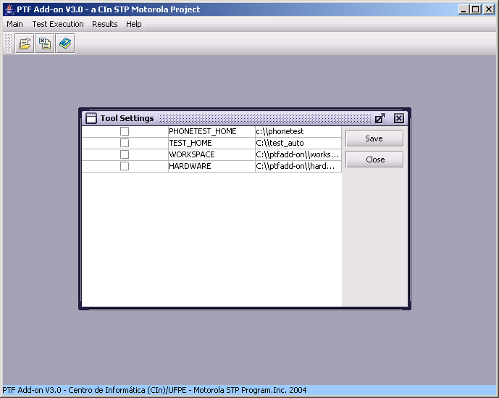
Figure 4-17: PTF Add-on configuration keys
Every time the tool is started, it checks this information in order to have means of executing the tests with PTF. In the case inconsistence, the environment will exhibit a warning message and will open the configuration form to the tester.
The idea of a workspace directory consists in an area to store the several executions of automatic tests. When the tester creates a new execution wizard definition, the workspace directory will be used as the default path of the needed files. Figure 4-18 shows the proposed directory structure to better organize the needed files during the process of testing. The given structure is created after saving the execution wizard steps of configuration, explained later. The structure of the directory is organized as follows:
- Platform directory: holds information about the used platform, currently P2K and Juix are used;
- Hardware directory: the hardware to be tested, as well as the PTF Add-on execution wizard file created by the tester;

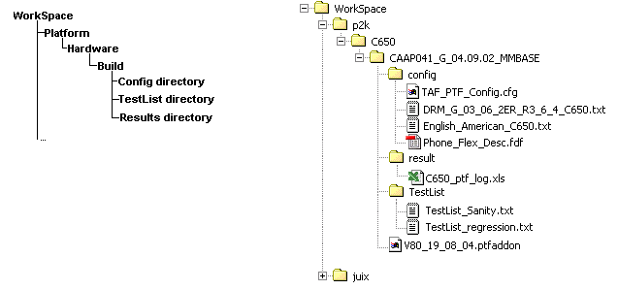
Figure 4-18: The Workspace structure directory
- Build directory: holds the files of a given build files of that hardware. Files like Flex, DRM and configuration files are stored on that directory;
- Config directory: configuration files like the DRM, Language definition and flex files are hold on this directory;
- Results directory: the directory containing the results from executions performed by the tester; It can be the same directory to redirect the PTF log file, as well as the generated report files in .xls format;
- Test List directory: holds information about the created test lists. The tester can organize the lists on its own way; for instance, the lists by the type of tests performed;
All new test execution wizard files created with PTF Add-on 3.0 uses the .ptfaddon file extension to identify the files created using the environment. The root of the Workspace directory will hold the files, as the default place.
When these configuration keys are set, the tester is able to execute tests. The first thing is to create a new Execution, as described in Figure 4-19.

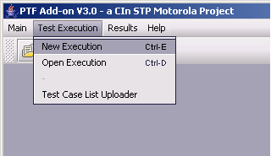
Figure 4-19: Create a new Execution
The result is the creation of a new execution wizard window shown in Figure 4-20, as described on the requirements on section 2.2. The wizard is comprised of five steps as described below:
- General Configuration: is the information concerning the test information; This information is used to create the workspace execution directories;
- Test List Builder: it is the test case list configuration step, where the tester indicates or creates the tests list;
- Configuration File: is the step to configure the PTF-TAF configuration keys values;
- Execution: it is the main step, where the tester starts and visualize the execution of the specified test list;
- Results: The last step with the description of the results of the executed test cases, allowing the tester to export the repot generated by the tool.

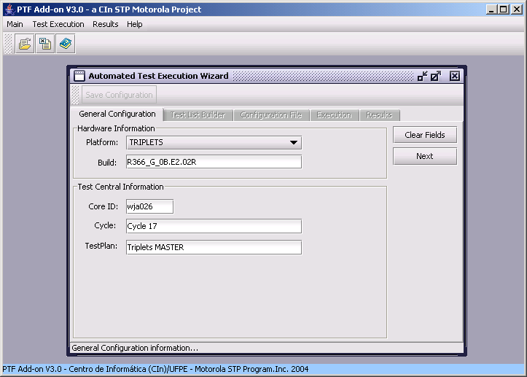
Figure 4-20: Execution Wizard Frame
The general configuration tab is the first set of information to be filled out. The fields are concerning the test execution as described on previous sections and are as follows:
- Platform: the used platform: P2K or Juix;
- Hardware: the hardware list;
- Build: the build to be tested;
- Core ID: the identification of the tester;
- Cycle: the description of the cycle;
- Test plan name: the description of the test plan;

It is important to note that these information must match the ones needed by the Motorola Test Central Repository, and therefore, must be taken from the test manager.
A click on the “Next” button takes the user to the Test List Builder tab. The test list builder is the component responsible for setting the test list file from a .jar file or from an existing test list previously created and saved. Figure 4-21 illustrates these two options of opening the required files to set the test list.

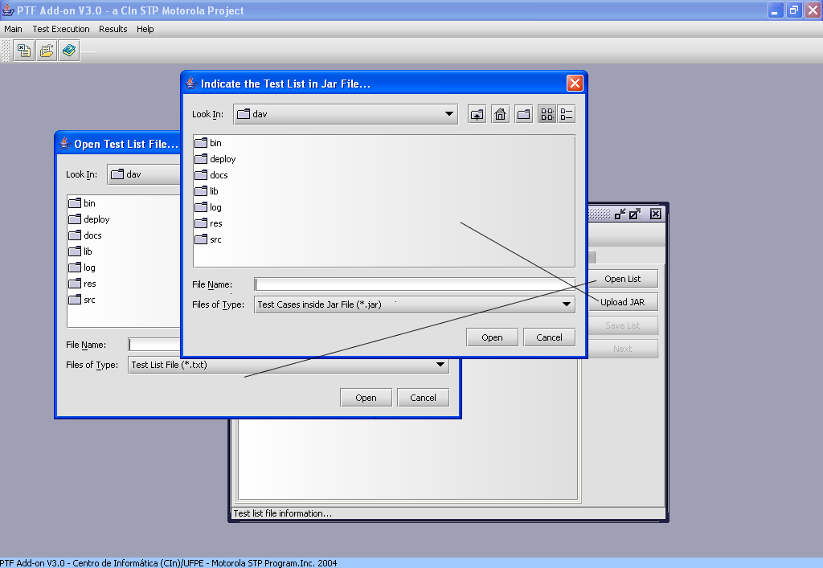
Figure 4-21: Selecting a test case list from .jar or .txt file
After choosing the file to be opened, the list of the test cases will be shown to the tester. This test list must be saved in a .txt file format. If the list was uploaded from a .jar file, then the environment will require the tester to save the list as a .txt file, as required by PTF. On the other hand, if the file was a .txt file, the tester just saves the configuration and the “Next” button will be available. Figure 4-22 shows the test cases list from either a .txt test list file or from a .jar file with the available the test cases. At least one test case must be chosen to save the test list, which is saved in a java-properties file format, the same used by PTF default test cases list file. One example of the test list can be seen on the appendices.
As the ‘Next’ button is clicked, the next step is to edit an existing PTF-TAF configuration file. The Configuration File tab is now shown and the tester can indicate which the configuration file in the .cfg extension just clicking on the ‘Open Conf File’ button, as shown in Figure 4-23. This is the default configuration file used during the PTF-TAF automated tests. After choosing the specified file, the configuration file is opened to the tester as a table, with the keys and its respective values, as shown in Figure 4-24. Since the file is on the java-properties file format, the first column specifies if the selected keys must be or not commented.

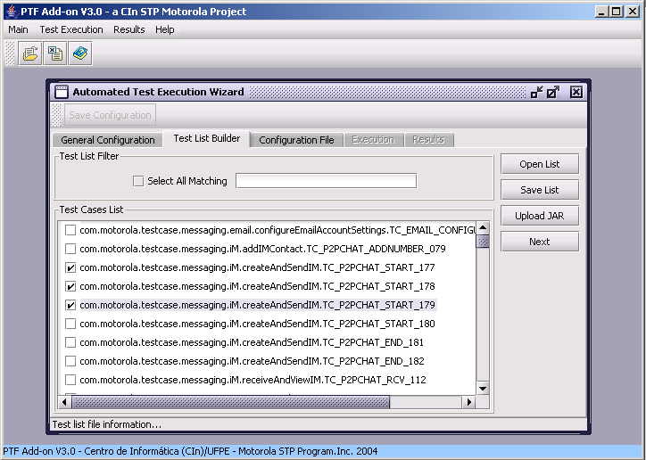
Figure 4-22: Defining the test cases list
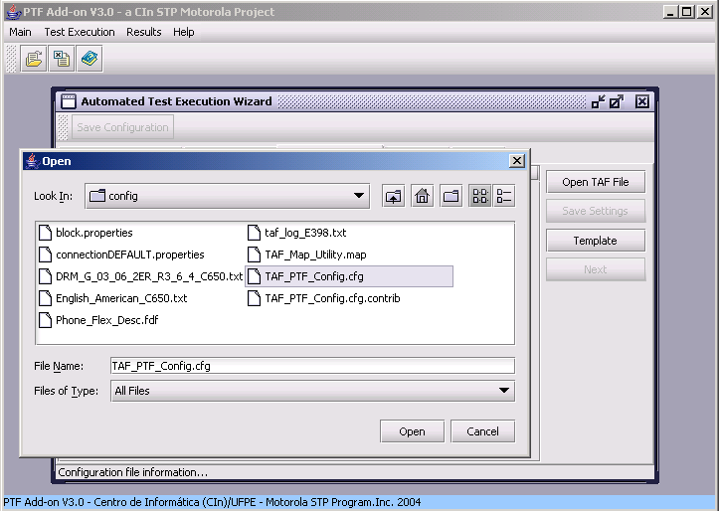
Figure 4-23: Selecting the configuration file
If the tester does not own a configuration file, then a new file can be created from a template, just clicking on the ‘template’ button. As a result, a PTF-TAF default file will be automatically created, showing the keys’ values. Furthermore, the tester can easily use the add-remove buttons to add or remove one of the rows of the configuration file. It is important to note that some of those key values are mandatory and, for this reason, the tester must specify and check these parameters, once they are needed to run the automated tests.

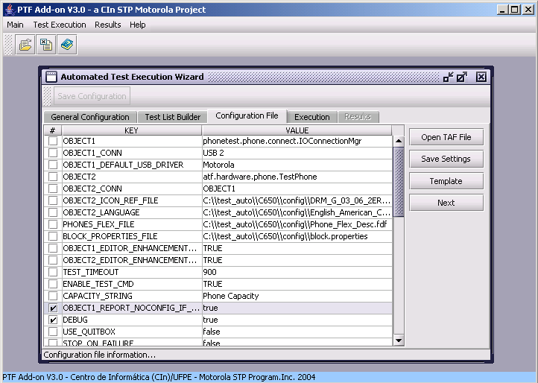
Figure 4-24: Opened PTF-TAF Configuration file.
When the tester confirms the configuration of the file, the tester has just finished the Environment Set Up step. The execution tab is then shown to the tester, allowing the start of the execution of the test case list specified on the Test List Builder. The Execution tab can be seen on Figure 4-27.
After the whole configuration process an execution wizard, the tester can optionally save the wizard execution configurations. The tester clicks on the ‘Save Wizard’ button, at this time enabled, as shown in Figure 4-27. In other words, the wizard window will be serialized as semi-structured file and saved with the (*.ptfaddon) extension as specified on section 3.1, enabling the tester to reuse that information of the execution wizard to execute the specified tests on the test list for a given hardware.
Valuable to note that after having saved the execution wizard configuration, the tester can reuse those steps once created and, without doubt, save time just choosing to open a created execution configuration file. As shown in Figure 4-25, the tester just indicates the wizard configuration file and the previous information are automatically filled on the PTF Add-on components once again, showing the Execution Step, as shown in Figure 4-27. As a result, the reuse of all the steps information is possible, enabling the tester to edit any configuration field, select more test cases on the Test List Builder TAB, and also changing some configuration keys, if necessary, on the Configuration File TAB. Finally, the tester can save another file using the same procedure at any moment.

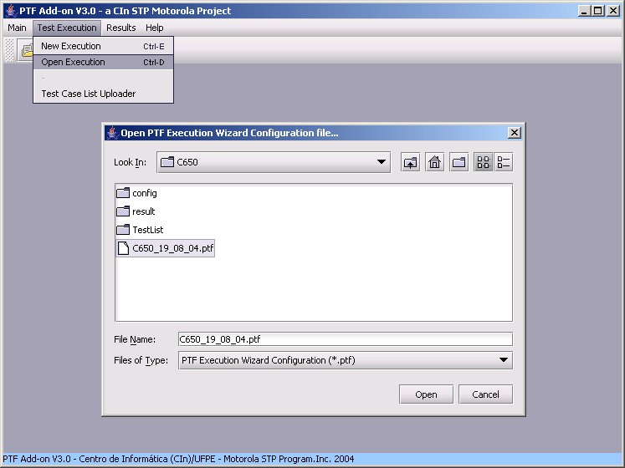
Figure 4-25: Opening an existing Execution Wizard Configuration file with .ptfaddon extension
In the case of multiple wizard configuration windows, the tester just creates a new window, or also opens an existing wizard configuration file, so that a particular window will be opened and the tester can perform the execution on each of the wizard as desired, as shown in Figure 4-26.
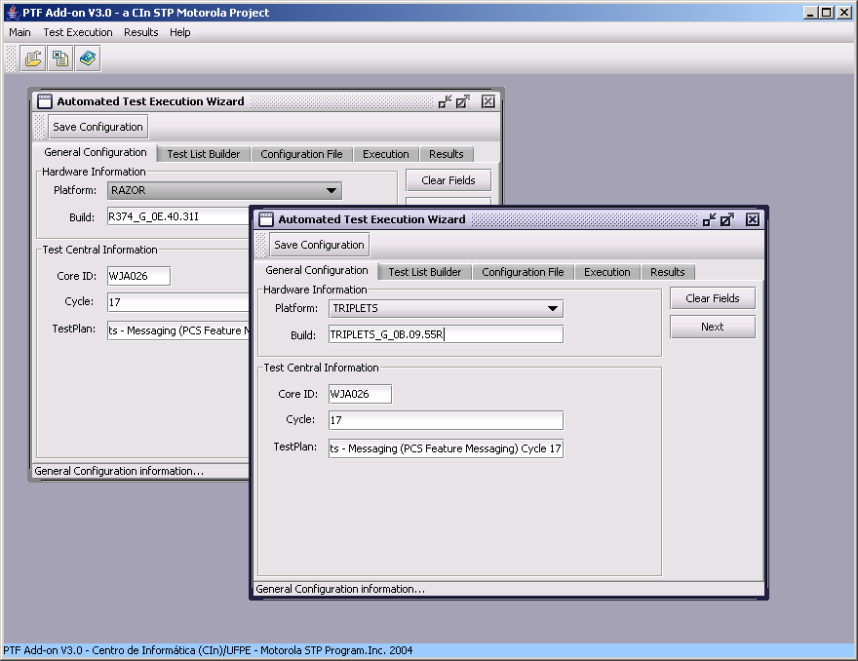
Figure 4-26: Multiple Configuration Wizard Windows

Test Execution

At this step, the test just begins the execution of the test cases specified by the test list. The information on this step specifies the information concerning the execution itself, distributed on different views, shown in Figure 4-27, and specified as follows:

- Executed Test Cases View: shows each executed test case during the execution while the tests are being performed and finished by PTF;
- Online Tests Execution Status View: shows the online information about the number of tests cases already tested, the number of tests that have passed, failed and not configured; as well as the current test case that is being tested;
- Execution Steps View: allows the tester to see all the steps from the selected finished test case from the Executed Test Cases View;
- Exception View: shows the tester all the different exceptions that happened during the execution of the selected test case from the Executed Test Cases View;
- Log View: shows the default PTF execution log output;

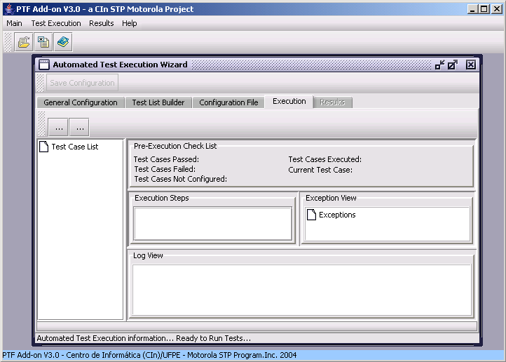
Figure 4-27: Execution TAB from the Wizard.
When the “Start” button is clicked, the execution of the tests starts. The Executed Test Cases, Online Tests Execution Status and Log View views are filled at the time each test case finishes is tested by PTF. When the tester clicks on a given finished test case on the Executed Test Cases View, the Steps and Exception views are updated with the information of that test case. Additionally, a process bar is provided on the bottom of the Execution wizard TAB, showing the partially tested test cases. A shot from an execution instant of an execution is shown in Figure 4-28.
One of the key functionalities of PTF Add-on is to enable the tester to perform multiple executions in particular wizard execution window as stated on the previous section. Similarly, the tester can then have different hardwares being tested at the same time, as shown in Figure 4-29. The only requirement is to have available USB ports, indicating on the configuration file the correct one, so that the behavior is the same as executing a single instance of the execution wizard window. Nevertheless, it is important to note that performance issues were not checked by this work.
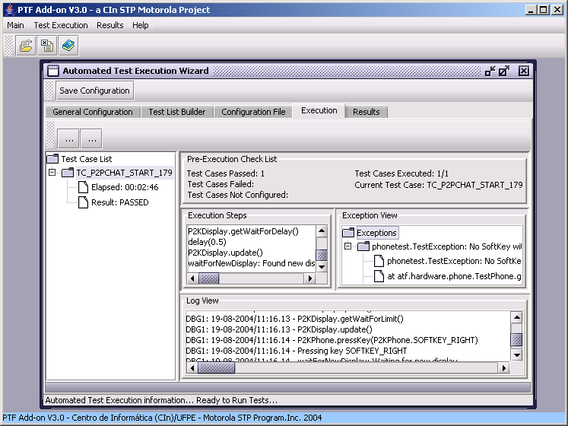
Test cases viewer
Log generated in real time
Exception throws
Online Test Execution Status
Steps viewer
Figure 4-28: Test Execution in process.
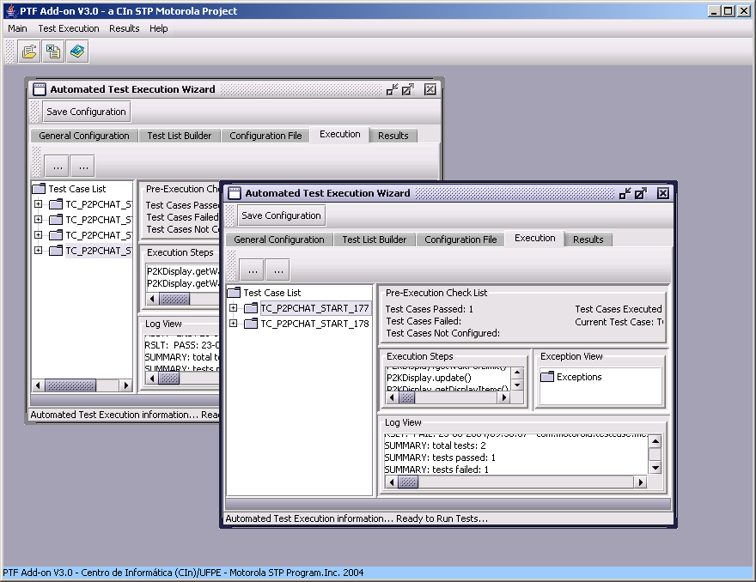
Figure 4-29: Multiple Execution Shots on different hardwares
As the tests are finished, the Results TAB will be shown with the results of all tested test cases specified in the test cases list shown in Figure 4-30. As a consequence, the tester can report the results, following the Report Generation step of the automated testing process discussed here.

Report Generation

The last and most important step is the report generation feature of PTF Add-on, once it shows the test results in a simple and very clear way, identifying the results of each test as shown in Figure 4-30.

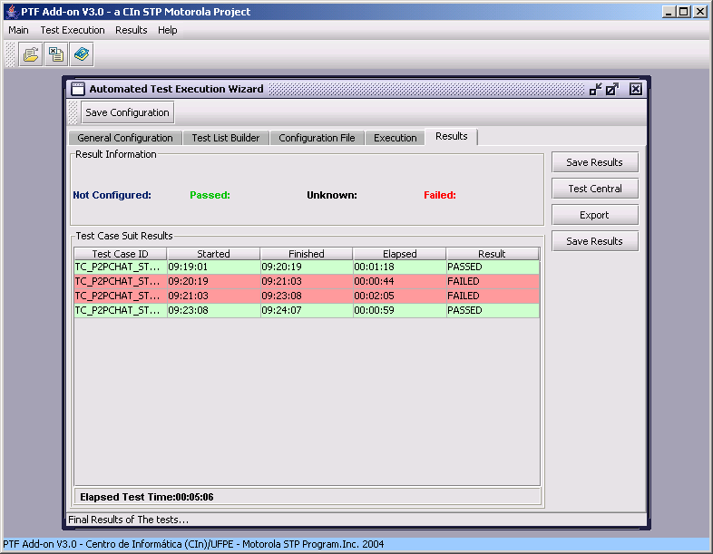
Figure 4-30: Results TAB
The report generation options are based on the test results shown on the Results TAB and are defined as follows:
- Generation of a Microsoft Excel .xls file with the test results and their status, allowing the tester to easily report the results to Motorola Test Central, for instance, if the network is not available. A result of a generated .xls file is shown in Figure 4-31;
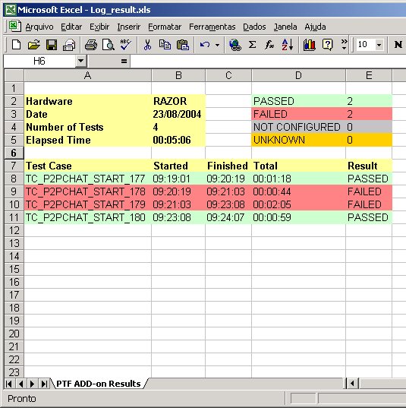
Figure 4-31: Generated Report from the Execution Results
- The most important feature of PFT Add-on is capability of sending the results directly to the Motorola Test Central repository shown in Figure 4-32, after tester has analyzed the results. As shown in Figure 4-33, the results status on the repository has different values from the generated ones. The passed result remains the same value and the others are:
  - Failed results are saved as Indeterminate, once the results need to be analyzed by the tester;
  - Not Configured and Unknown Results are reported as blocked.
The semantics about each test status may be seen at the Motorola Test Central User Guide [Test Central Guide, 2003].
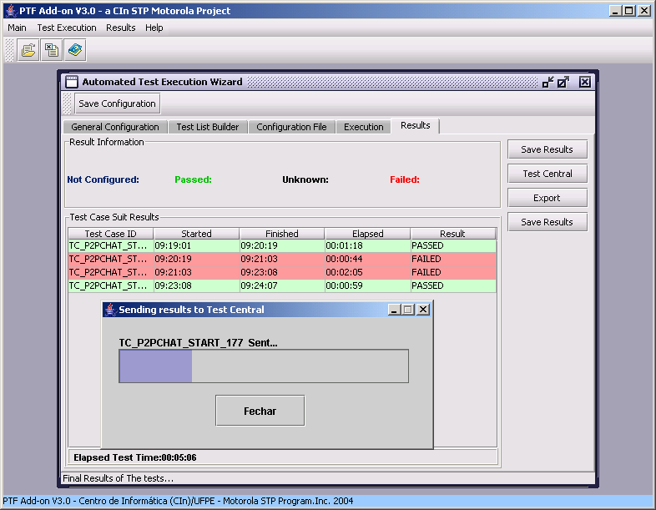
Figure 4-32: Sent Results on the Motorola Test Central
After the Report Generation step, the tester can continue the cycle of automated tests with PTF Add-on, returning to section 4.1. As explained, the tester can perform multiple execution wizards, and therefore, multiple tests on different hardwares.

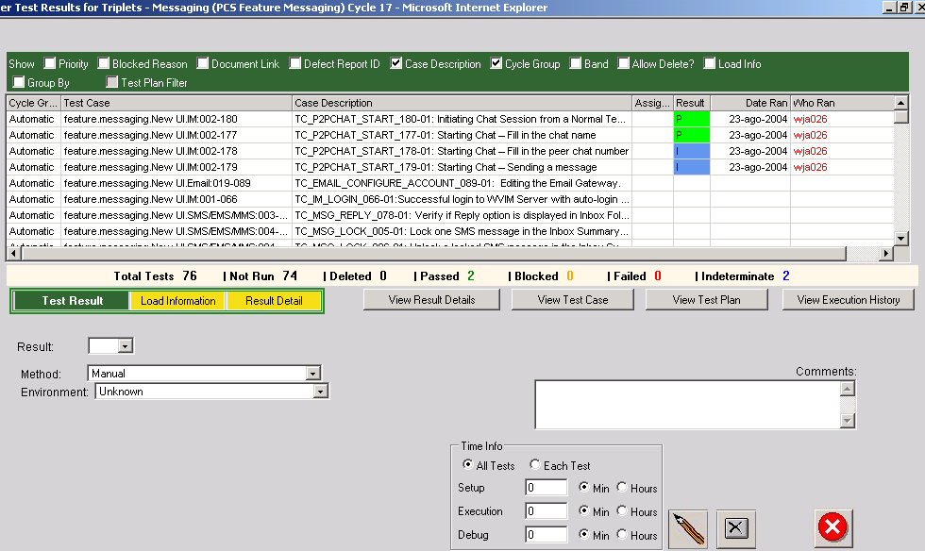
Figure 4-33: Sent Results on Test Central Repository
PTF Add-on has a utility to generate the same report types from an existing PTF generated log file, in the case of an execution of PTF without this environment. This is accessed on the Results Main Menu and then the utility as shown in Figure 4-34. The tester specifies the log file, and the results will be parsed on the same way the execution wizard does. On this way, the tester chooses the export type: an .xls report or sends the results to the Motorola Test Central. On the last case, the tester must additionally specify its core ID, the test plan name and the number of the cycle. The behavior is the same as presented on this section, and is also shown in Figure 4-34.

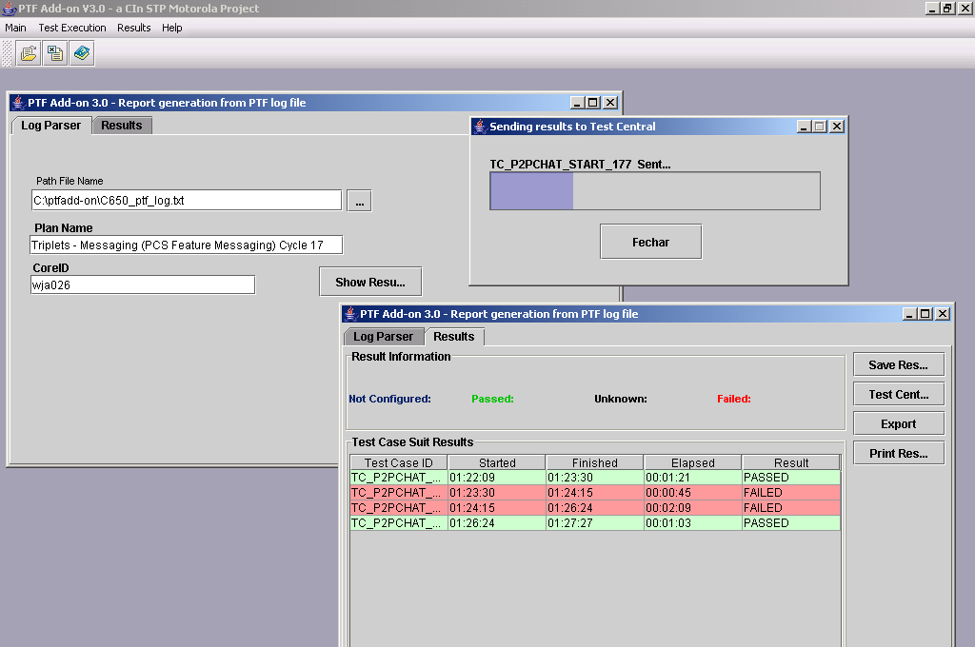
Figure 4-34: Report Generation Utility

Conclusions and Future Work
In order to reduce the automated testing process efforts with PTF Add-on, a primary impetus for reducing this effort was first identified: the lack of management of the PTF generated results, which are difficult to manage. For this reason, a parser was developed, in order to have means of generating a consolidated results report from the PTF log files and, as a consequence, creating different destination types from the results like creating an .xls file or sending the results directly to the Motorola Test Central repository.
Since PTF presents a poor user interface, the problems were completely solved using a wizard-like window, allowing the tester to have a systematic testing process with PTF. Productivity is now better achieved with friendlier user interface functionalities such as saving that wizard definition for a later reuse and visualizing the online information about the execution, as well as making multiple test executions possible, just creating or opening new wizard windows.
Although this version of PTF Add-on has changed the culture of the PTF use on this site, some improvements are proposed in order to achieve better results:
- The Configuration File wizard TAB could be improved using a systematic process of requesting each of the mandatory fields, in order to avoid erroneous information when reusing a configuration file;
- The execution wizard file can be extended to a client/server component, allowing the test manager to publish the definitions of the wizard. This functionality is being identified here due to possible invalid identification of the test information provided on the wizard, such as the test plan name and cycle, which are essential to send the results to the Motorola Test Central repository. The idea is shown on the diagram below and explained as follows:
  - After creating the cycle and test plan for a given build of a hardware, the test manager assigns an automated test execution definition to a given tester. The definition contains the correct cycle and test plan name identifications, as well as the tester core ID. This information is exchanged using Web Service SOAP implementations with the repository server, which saves the information on a local database, so that the tester can open PTF Add-on and get the information about in which build he will be performing automated tests. Furthermore, the test reports could be easily generated either from the repository or from the PTF Add-on, as it’s already implemented.


Test Central
Repository Server
- The deployment model could use the Java Web Start schema [Kim, 2001], to assure the transparent deployment of the latest version of PTF Add-on.

PTF Add-on represents a great contribution to the automated testing activities at different Motorola sites such as BDC and CIn-STP, which directly contributed on the achievement of this work. Without doubts, the CIn-STP courses were vital to the implementation of this work, due to the quality of the professor’s lessons and culture held during the period of this Internship. Information from the Urbana-USA Motorolans contributed with the information about the Test Central Repository, allowing us to directly send the results from the tests. Finally, acknowledgments to the CIn-STP teams, specially the Messaging and TDMA ones, must be given for the initial steps with the automated testing process with PTF, as well as each scholarship and person from this site, as it would be unfair to forget their names.

References
[Dustin at al, 1999] | Elfriede Dustin, Jeff Rashka, John Paul (1999): Automated Software Testing: Introduction, Management, and Performance. Addison Wesley
[PTF, 2003] | Motorola Phone Test Framework (PTF).
[Cruz, 2003] | Cruz, Luckerson C. (2003): Proposed Monograph: PTF Add On. Internship Motorola Program. Recife-PE, Brazil.
[Filho et al, 2003] | Audir de Araújo Paiva Filho, Bergson Brito Barros, Humberto Rocha de Almeida Neto (2003): Proposed Monograph: PFT Add-on - CEL (Configuration, Execution and Log Generation): Internship Motorola Program. Recife-PE, Brazil.
[Test Central, 2003] | Motorola’s Test Central.
[Gosling & McGilton, 1996] | James Gosling & Henry McGilton (1996): The Java Language Environment: A White Paper. Sun Microsystems, May 1995. at ftp://java.sun.com/docs/JavaBook.ps.tar.Z (1998)
[JavaTech-1, 2003] | Reading files from JARs and Getting Started with the JMX http://java.sun.com/developer/JDCTechTips/2003/tt0122.html#1
[TAF, 2002] | TAF: Test Automation Framework
[W3C Schema, 2001] | XML Schema Definition - http://www.w3.org/XML/Schema
[Satta, 2000] | Satta, Giorgio (2000): Parsing Techniques for Lexicalized Context-Free Grammars. In Proceedings of the 6 th IWPT, Trento, Italy, February, 2000. http://citeseer.nj.nec.com/satta00parsing.html
[Ryan at all, 1998] | C. Ryan, M. O'Neill and J. J. Collins (1998) Grammatical Evolution: Solving Trigonometric Identities: In proceedings of Mendel 1998: 4th International Mendel Conference on Genetic Algorithms, Optimisation Problems, Fuzzy Logic, Neural Networks, Rough Sets. Technical University of Brno, Faculty of Mechanical Engineering. http://citeseer.ist.psu.edu/article/ryan98grammatical.html
[Canton, 1998] | Canton, Murray R. (1998): Object Oriented Project Management. John Wiley & Sons, Inc.
[Gamma et al, 1994] | Erich Gamma, Richard Helm, Ralph Johnson, John Vlissides (1994): Elements of Reusable Object-Oriented Software. Addison-Wesley Professional Computing Series
[JFC, 2003] | Java Foundation Classes (JFC/Swing) specifications: http://java.sun.com/j2se/1.4.2/docs/api/index.html
[Sosnoski, 2002] | Dennis M. Sosnoski (2002): XML and Java technologies: Data binding with Castor.  http://www-106.ibm.com/developerworks/xml/library/x-bindcastor/
[Sengupta et al, 2003] | Avik Sengupta, Andrew Oliver and Rainer Klute (2003): Reading and Writing Excel Files with POI. http://www.onjava.com/pub/a/onjava/2003/04/16/poi_excel.html
[Test Central Guide, 2003] | Test Central Site. http://iauto.mot.com
[Kim, 2001] | Steven Kim (2001): Developing and distributing Java applications for the client side  http://www-106.ibm.com/developerworks/java/library/j-webstart/ on 2000/07/13

Appendices
- Wizard XML Serialization – execution.ptf
<?xml version="1.0" encoding="UTF-8"?>
<executionWizard id="1090099676616" date="2004-07-17" time="18:27:56">
<hardware>
<platform>TRIPLETS</platform>
<build>LIBCC0394RTRIPLETS</build>
</hardware>
<testCentralInfo>
<coreId>WMJ011</coreId>
<cycle>P2K</cycle>
<plan>REGRESSION</plan>
</testCentralInfo>
<neededFiles>
<config>C:\TAF_PTF_Config.cfg</config>
<testList>C:\Testcase_Exec_List.txt</testList>
</neededFiles>
<testList>
<testCaseId>
com.motorola.testcase.messaging.iM.addIMContact.TC_P2PCHAT_ADDNUMBER_079
</testCaseId>
<testCaseId>
com.motorola.testcase.messaging.iM.createAndSendIM.TC_P2PCHAT_START_177
</testCaseId>
</testList>
</executionWizard>

- PTF Log Grammar used to parse the PTF Log (imcomplete)
"Start Symbol" = <PTF-Log>
! ------------------------------------------------- Sets
{String Chars} = {Printable} - ["]
! ------------------------------------------------- Terminals
StringLiteral = '"' {String Chars}* '"'
startToken = 'RSLT: START: ' StringLiteral
endToken = 'RSLT: END: ' StringLiteral
resultToken = 'RSLT: PASS: ' StringLiteral
stepToken = 'DBG1: ' StringLiteral
exceptionStepToken = StringLiteral 'Exception' StringLiteral
exceptionCompToken = 'at '
! ------------------------------------------------- Rules
<configuration> ::= StringLiteral
<classname> ::= StringLiteral
<package> ::= StringLiteral

<start-statement> ::= startToken
<end-statement> ::= endToken
<result-statement> ::= resultToken
<package> ::= <classname> '.' <package> | <classname>

<class-declaration> ::= <package>

<exception-complement> ::= exceptionCompToken <package> <exception-complement> | exceptionCompToken <package>

<exception-statement> ::= exceptionStepToken <package> <exception-complement>

<step-statement> ::= <exception-statement> | stepToken

<steps> ::= <steps> <step-statement> | <step-statement>

<testcase> ::= <start-statement> <steps> <end-statement> <result-statement>

<testcases> ::= <testcases> <testcase> | <testcase>

<testcases-list> ::= <testcases-list> <class-declaration> | <class-declaration>

<PTF-log> ::= <configuration> <testcases-list> <testcases>

- Test List file with the chosen test cases (without starting with ‘#’) - testlist.txt
com.motorola.testcase.utility.phonebook.TC_ADD_ENTRY_PASS
com.motorola.testcase.utility.phone.TC_WAIT_FOR_TRANSIENT_NOTICE_PASS
com.motorola.testcase.utility.phone.TC_VERIFY_DIALOG_PASS
com.motorola.testcase.utility.phone.TC_REJECT_DIALOG_PASS
com.motorola.testcase.utility.phone.TC_PRESSKEY_PASS
#com.motorola.testcase.utility.phone.TC_NEGATE_UTILITY_FUNCTION_PASS
#com.motorola.testcase.utility.phone.TC_CHECKSCREEN_PASS
#com.motorola.testcase.utility.phone.TC_ACCEPT_DIALOG_PASS
#com.motorola.testcase.utility.navigation.TC_VERIFY_LIST_ORDER_PASS
#com.motorola.testcase.utility.navigation.TC_SCROLLTO_PASS
#com.motorola.testcase.utility.navigation.TC_SCROLLTO_AND_SELECT_PASS
#com.motorola.testcase.utility.navigation.TC_LAUNCHAPP_PASS

Backus-Naur Form: formal notation to describe the syntax of a given language.
Java Data Base Connection.
operation that is stored with the database server written in SQL

